MY TESTS
Please in the next version releases, please indicate what was adjusted/solve by indicating the item number below
#1 BUG:
[buy reverse?] is inverted !!!
Need to adjust… if it is enabled, then buy reverse, but it is not doing it, it is buying reverse if it is not enabled…
#2 BUG:
The name of the field is [NEXT Stake due MG], this mean that when bot loss, it should get the lost stake value, in this case below = 1 and applies the [MG multiplier] and save there the value that will be the NEXT Stake value for the next MG entry…. Look, it is not doing it, the bot is updating with the lost value…. You need to adjust this logic.
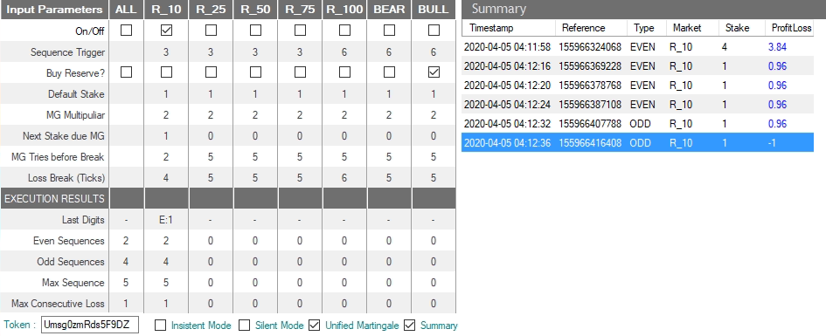
I saw that it seems you´re using [NEXT STAKE DUE MG] as a loss counter… is it ???
If yes, in this case, I suggest you to create another field/variable in EXECUTION RESULTS named [# LOSS in MG] for this… And
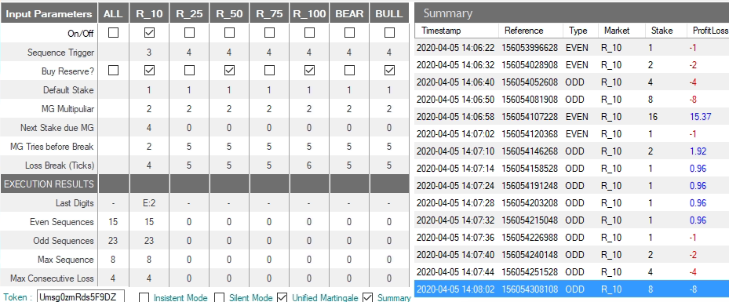

#3 BUG:
When I edited the [Next Stake MG] value, the bot displayed it in bold and when it win, it didn´t set it to 0 and all next buy actions was considering it instead of the [default stake], because it was not in MG mode anymore…
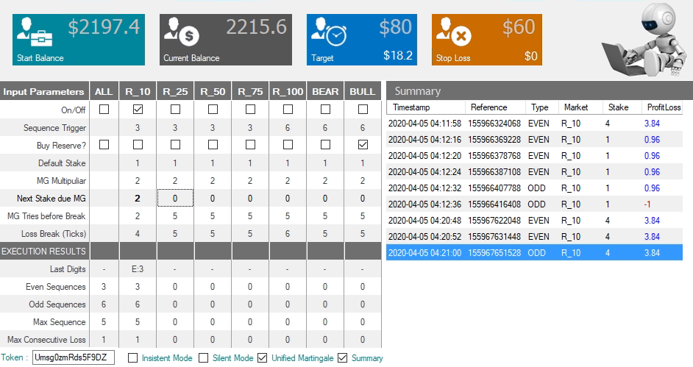

#4 ISSUE:
The [Next Stake due MG] is double not int !
In this example, the value was to be: 0.35*2.1= 0.73 and it calculated as 1 !!!!
Why 1 ?????
The bot made just the first trade, then stopped to trigger after it updated the value (1) on [Next Stake due MG]… I think it gave some internal error…
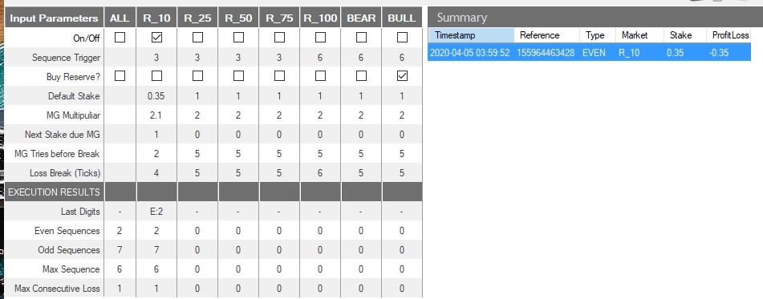
#5 BUG:
Still not playing the sound when bot loss !!!

#6 BUG
[Insistent mode] = off not working…. In this example, despite it be as off (mot enable) the bot made 3 consecutive buy action for O:4, O:5 and O:6 and if it is off, it should be trigged only if = the [sequence trigger] (O:3 or E:3) but it still triggering as “>=”
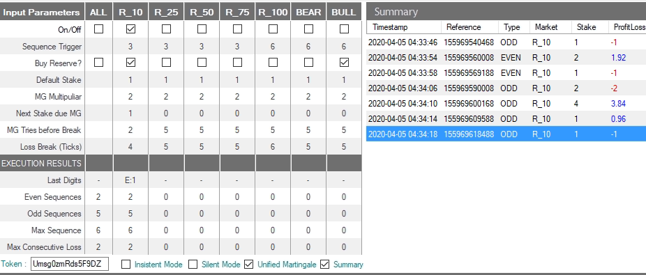
And in this example, of an E:11 wave, it also continue constantly buying.. I understand that when in MG mode (loss), ok it will try, but in the 2 win it was supposed to wait for the next tick, due to the fac that the previous was also a win and reseted the MG mode. This is to show thar the “[ ] insistent mode” = off was not working as should be.
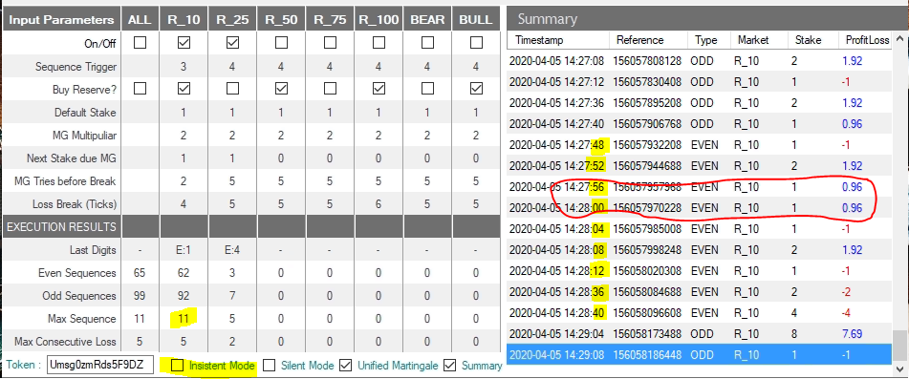
#7 ISSUE:
Until [Next Stake due MG] not working accordingly as I´m saying (explained above), you will not be able to implement the [Unified Martingale] logic !!! please correct the [Next Stake due MG] to have the value for the NEXT Stake not the value of the stake that was lost
#8 ISSUE:
[runs] is not being calculated (it is Win+Loss)
[execution time] (chronometer) is not being displayed. If the bot is paused, this counter should pause too (as was specified in the Fields Specifications file).
[Account] – the final part of the user´s account code is not being replaced by "XXXX", as was request in the Field Specification document
[Profit/Loss] Can be removed from the bottom of the form…

#09 ISSUE - INTERMITTENT:
After several times running the bot, closing the app, pressing stop/starts in order to check app behavior, I saw the the bot stopped working, it makes the sound of the buy trade attempt and doesn´t conclude it and stay freezed. It is a very frustrating situation ….
In parallel I decided to run that other similar bot that I have, DFOXZ, using the same token and it worked fine, doing the buy actions, etc…etc… DFOXZ worked normally without any lag… but when return to our bot, it does not trigger the buy actions and was freezed !!!!
It is necessary to discover what is causing this… Need to ask in forums, because I don´t know… Maybe send some kind of reset command thru the API to release the app_id to make trades again… something that our bot is doing is generating this condition… It seems binary is suspending due some mal-function… In this case below, it was working fine than suddenly freezed !
I´M TESTING MORE… AND MORE…. IN ORDER TO TRY SEE HOW MANY TIMES IT HAPPENS AND TRY SEE WHAT COULD BE CAUSING IT.. IN THE MEANTIME, GO FIXING ALL THESE OTHER POINTS I´M INDICATING… I´M SURE YOU´LL SOLVE
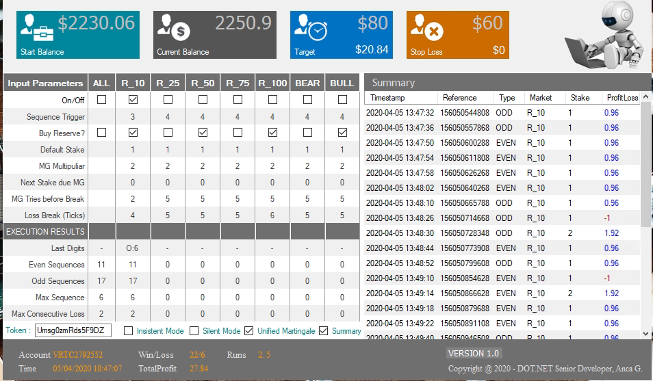

#10 PENDENT:
The bot is updating only [input parameters] fields in the .cfg file and is still pending make [Your token]+[Target]+[StopLoss] be editable fields and also update the correspondent keys the .cfg file and also needs to update in .cfg file the [Max Sequence Registered] per market when the app is CLOSED or STOPPED.

#11 PENDENT MILESTONE
The bot need to check this API / JASON URL below, using the user´s token as URL parameter, in order to check if it is authorized to run the bot.
https://sheet.best/api/sheets/bd8f3cf4-ffef-4845-a3b0-4f24c6b77827/TOKEN/Umsg0zmRds5F9DZ
This hash bd8f3cf4-ffef-4845-a3b0-4f24c6b77827 needs to be in the .cfg file named as Param_Hash
The complete URL of the API need to be mounted inside the code
Can only run the bot if Status = 0
[{"TOKEN":"Umsg0zmRds5F9DZ","STATUS":"1"}]

If the JASON returns STATUS=0 or return just “[]” then need to display a popup, over the form with the message of Param_Msg1 key, that also needs to be included in the .cfg file

#13 PENDENT MILESTONE
Show last buys in the top (first) line of the summary grid, not in the bottom... hide/show the summary adjusting the width of the main form. I suppose it will be adjusted at final layout adjustments...

